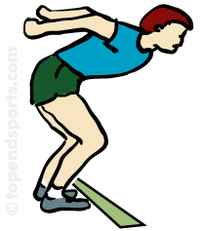
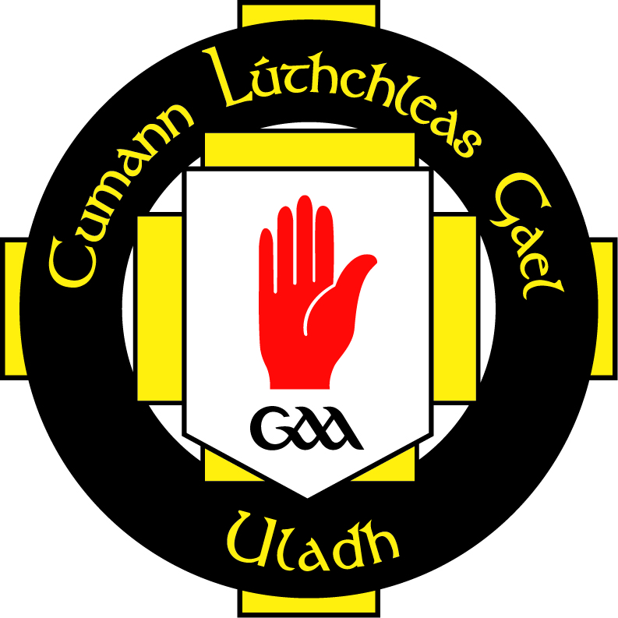
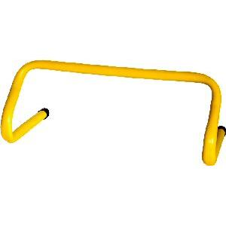
STATION 2: JUMPING
Activity: The Grand National

RULES – HOW TO PLAY

- Set up obstacles as shown

- Use line to start, place ladder to jump through, place a cane on 2 cones, on the way back place a series of hurdles and hoops

- Jump through spaces in ladder

- Jump over pole and run to start of hurdles

- Jump over hurdles and land in hoops to finish over line

- ‘Hi 5’ next in line

- 1Pt. for each complete run

FOCUS
- Coordination of jumping through, over and into obstacles
Finish Line
HARDER
Different ways of moving through the ladder – 2/1 foot combinations
Use smaller hoops & taller hurdles
Use different directions to jump over hurdles (Jump forward 2 spaces then back 1 space)
Can you jump sideways over obstacles

EASIER
Take out either the hoops or hurdles
Walk run through the ladder
Use rope/domes instead of hurdles

COACHING POINTS

HEAD
Look where you’re going, be aware of equipment, encourage player to keep their head up looking forward where ever possible
HANDS
Swing your arms forward after take off to control body
When taking off 2 feet both arms work together
FEET
Bend your knees on all landings to help prevent jarring of joints
Use the ‘Balls’ (Front Part) of your feet to jump off and land on

EQUIPMENT

Hoops

Cones

Hurdles

Ladder
Copyright Ulster Council GAA 2009

